St. Francis Xavier Secondary School

Catholic School Council (CSC) Minutes of General Meeting

Thursday, February 8, 2024

**Meeting called to order @ 6:30 pm**

|  |  |
| --- | --- |
| **Attendees** | **Present** |
| Principal Ferdinando Tantalo | Yes |
| VP Derek McWilliam | No |
| VP Claudia Lehecka | Yes |
| Chaplain: Betty-Ann Pickett | Yes |
| Teacher Representative | No |
| Student Reps (SAC): Irene Theratil | Yes - Online |
| Claudia Molina – Leupolt – Chair | Yes |
| Shafqat Shan – Treasurer | Yes – Online |
| Nina Guha – Co-Secretary | No |
| Caroline Roach – Co-Secretary | Yes |
| Renata Kupresak – OAPCE Rep | Yes |
| Julie Sadhu – Parish Rep | No |
| Debleena Chowdhury – Parent Rep | No |
| Anjani Kesharwani – Parent | Yes |
| Karen Canlas, Parent | No |
| Suzanne Nunes, Parent | No |
| Diane Paterson, Parent | No |

**Trustees:**

Thomas Thomas – Not present

Stefano Pascucci – Not present

**Call to Order**

Meeting was called to order by Claudia Molina - Leupolt followed by the Opening prayer by Ms. Betty-Ann Pickett (Black History Month) and Land Acknowledgement by Claudia Molina - Leupolt.

**Motion of Approval**

Motion to Approve minutes from January 11, 2024 CSC meeting.

* Approved by: Renata Kupresak and Caroline Roach

Motion to Approve Agenda for February 8, 2024 CSC meeting.

* Approved by: Renata Kupresak and Caroline Roach

**Trustee Report by Trustee Thomas Thomas – Not present**

**Student Council (SAC) Report by: Irene Theratil**

Events planning:

* Started New Semester
* Bell Talk Day – Council members got Bell to donate hats and other swag that was distributed to students.
* Black History Month events are going to be posted
* DECA Members gave a presentation – Kaityln and Candida – Feb 29 is Café night and charity fund raiser for SICK Kids. Hundreds of Students attend.
* Motion to give $500 to DECA for Café Night – approved by Caroline Roach and Renata Kupresak

**Chaplain’s Report by Chaplain Betty-Ann Pickett**

* In January the Rosary Group was present and prayed 10 Hail Mary’s and welcomed students to join in.
* Ash Wednesday is on Feb 14 and the Liturgy proclaimed in the first period.
* Practice pray, abstinence and almsgiving. Discuss the relevance of Lent.
* Feb 13 – Pancake Tuesday. Hospitality team will prepare pancakes for the students at school.

**Teacher’s Report: By Principal F. Tantalo**

* No update at the moment - Looking for a new Teacher Rep

**Parish Representative – Julie Sadhu**

1. CWL Contest and Award – **Date: February 16, 2024.**

Excerpt from SFX Church bulletin included. Participation encouraged.

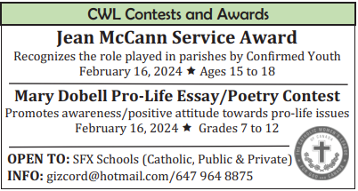

1. Parish Lenten Mission **– Date: March 4-6, 2024 between 7 pm and 8:15 pm.**

Excerpt from SFX Church bulletin included. Participation encouraged.

1. Steubenville Conference Details: **Date: June 28 – 30, 2024**.

Excerpt from SFX Church included. Participation encouraged.

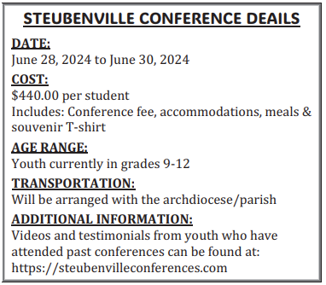

1. Continue to pray for the Silver Jubilee Celebration of St. Francis Xavier Church.

**OAPCE Representative – Renata Kupresak**

* 85th Anniversary of OAPCE – revamp of logo and website – annual Conference Apr 12 and 13, 2024. Minister of Education and Archbishop Leo will attend
* Parents perspective – workshop online 7pm on Feb 13, Tuesday.

**Treasurer – Shafqat Shan**

Current Balance at $1213.14. Same as before.

* Motion to give $500 to DECA for Café Night – approved by Caroline Roach and Renata Kupresak

**Chair’s Report: Ms. Claudia Molina-Leupolt**

* Nothing to report

**Principal’s Report: Mr. Ferdinando Tantalo and Ms. Lehecka**

* OSSLT – Grade 10 and Gr 11 students. Literacy test will run through the English class. They can write the exam during class. OSSLT will be during Period 1 and 2.
* Year books have arrived and they have been distributed.
* Semester 1 Report Cards on February 13.
* Course Selections for all grades – presentations will take place next week Mon and Tues to discuss about my Blueprint and how to use it. Grade 12 grad and prom will be discussed there as well. All tickets will be on School Cash Online after March Break.
* Semi-Formal – scheduled end of February. Communication to go out soon. Tickets to be purchased on School Cash Online.
* Child and Youth Worker – Managing Stress in Teens – Workshop – Online – February 28 – 2 hour zoom session.
* Reminder to parents to be careful during Drop-off as Student Safety is paramount. Might need to look at getting signage or a municipal officer to look at ticketing drivers that are not respecting the Kiss and Ride Rules. Picture attached for reminder.

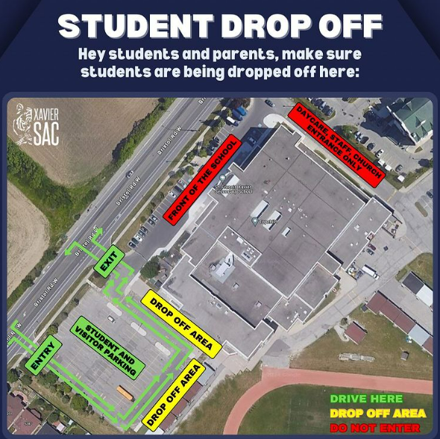

* Reminders to children are done during assemblies. Attendance, pick-up drop off and usage of lockers to store jackets and backpacks.
* Keeping bags in the lockers - Mr. Tantalo spoke to SAC – Irene for feedback. Bags are fairly heavy but getting to class on time might be a challenge if they have to frequent the lockers. It might be a big task in a larger school to have the children go back and forth.
* Looking at doing two lunches next year instead of three lunches. Do we have the capacity to make it work (will the cafeteria be over full? Or will the atrium be over crowded?) and will it help with logistics (time in-between classes) and will it be favourable to students (socializing, mingling and relaxing during the school day).
* Infractions of students – such as coming late, not wearing uniform, will be sent out to parents once approved by the office. After the first four infractions, and upon reminding students, parents will be briefed of the repetitive unacceptable behaviours.
* **HVAC Upgrade Update -** Mr. Ferdinand Tantalo will provide an update on the status.
  + Jan 11 Meeting **-** Status Quo from the last meeting: It remains that only 36 Heat pumps were replaced out of the 156 Heat pumps that needed to be replaced since the Summer of 2023 due to logistics issues and supply chain issues.
  + Jan 11, 2024 Meeting - They are prioritizing rooms where the HVAC is not performing at optimal capacity. Mr. Thomas Thomas was present and acknowledged that the HVAC upgrade was a problem.
  + Feb 8, 2024 Meeting - Library heat pumps are now fixed as it was not working. Over the Christmas break some of the bigger places were worked on.

**Tentative Future Meeting Dates (5 per year)**:

Thursday, April 4, 2024 at 6:30 pm

**Motion to adjourn the meeting**

* Approved by Caroline Roach and Renata Kupresak

**Meeting adjourned @ 7:21 pm**